**Assignment No.: 12**

**Title :** Frame the suitable assignment to perform computing using BIA tools effectively

**Aim:** Frame the suitable assignment to perform computing using BIA tools effectively

**Objectives:**

* To study the Business intelligence.
* To perform the computation using BIA tool like Kettle

**Theory :**

**Kettle:-**

The Kettle repository is a workspace that the data integrator works on. This workspace is a physical region of the hard-drive that is designated exclusively for Kettle. In the repository, all information about transformations, jobs, schedules, etc. is stored. The repository concept promotes re-usability, which in turn saves time and effort. We can create a new repository in two ways:

1. Kettle database repository: This repository uses a central relational database to store the ETL (Extraction Transformation Load) metadata.

2. Kettle _le repository: This is a repository stored in a _le in a certain folder.Creating a repository through Kettle database repository:-

Step 1: In the Repository Connection dialog box click on the + button. The Select the repository type dialog box will appear.

Step 2: Select Kettle database repository and click on OK.

Step 3: Now in the Repository information dialog box click on the New button.

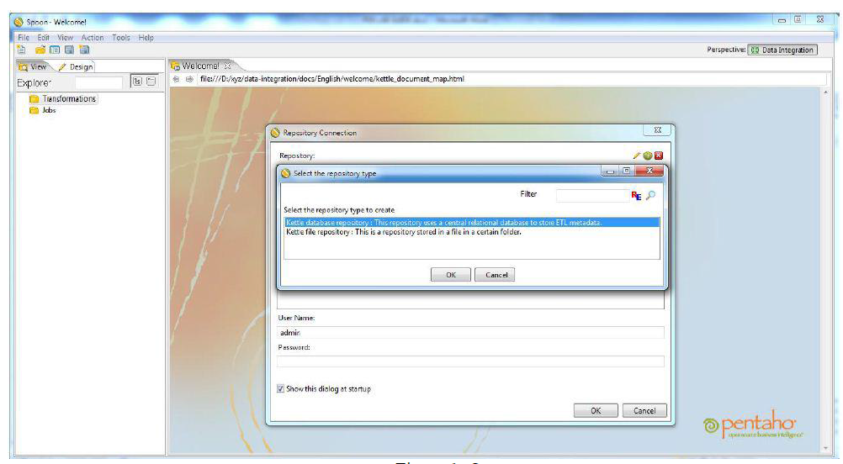

Figure:1

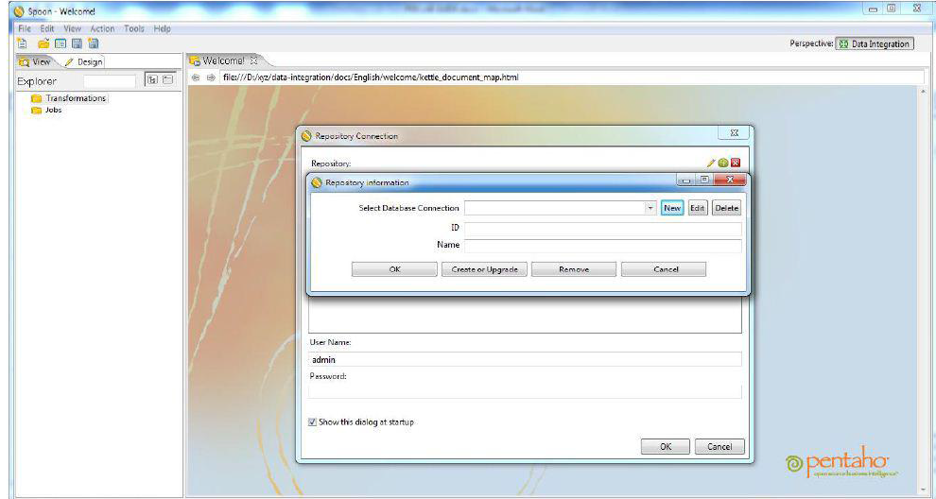

Figure:2

Step 4: In the Database Connection dialog box give a name in the Connection Name textbox, select MS SQL Server in the Connection Type list, and select Native (JDBC) in the Access list. In the Settings level, provide Host Name (Example: localhost/machine name/servername), Database Name, Instance Name (optional), User Name and Password.

Step 5: Now click on the Test button to see the connection status.

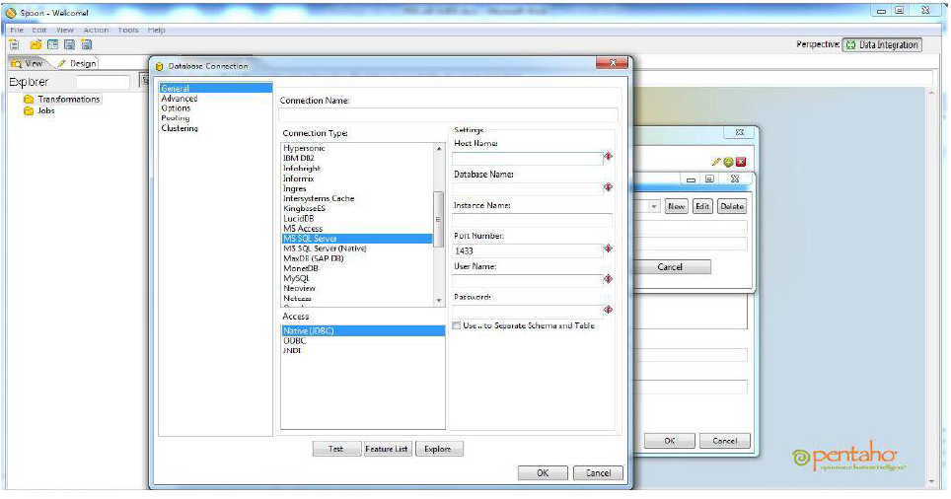

Figure:3

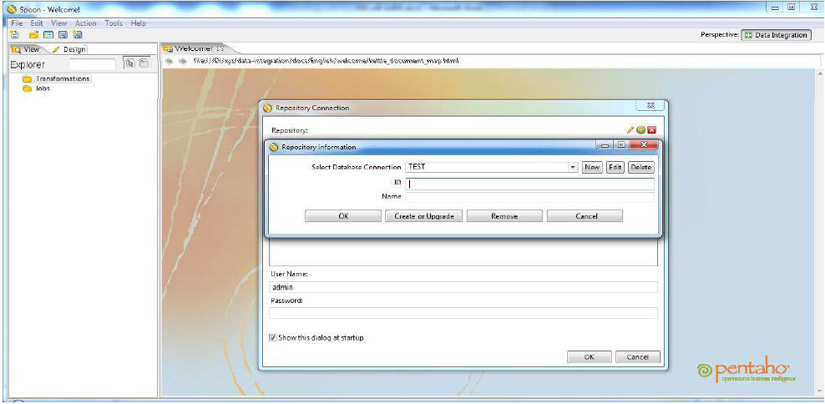

Figure:4

Step 6: In the Repository information dialog box, select the database connection from the drop down box, provide ID (to be displayed in spoon title bar) and Name (the actual name of the repository) and click on the Create and Upgrade button.

Step 7: In the OK dialog box, in response to the question, "Are you sure you want to create the repository on the speci_ed database connection?," if you click on the No button, everything will be created in the database and if you click on the Yes button, it will ask for a dry run.

Step 8: In the Dry run dialog box click on Yes, if you want to see the SQL statements as well as make some modi_cation. Else click on the No button.

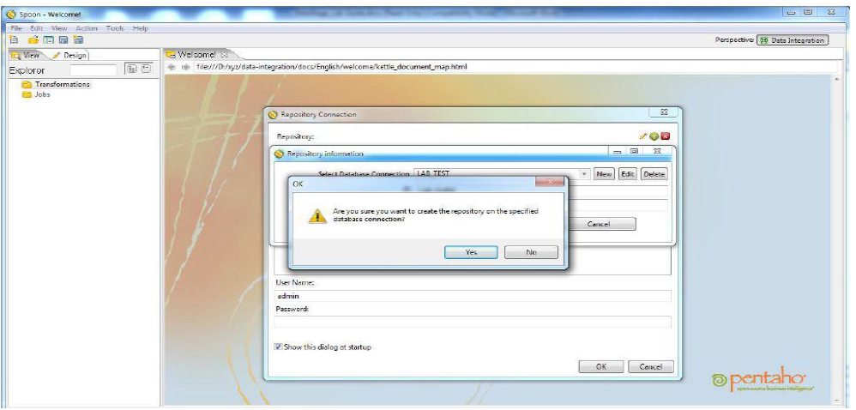

Figure:5

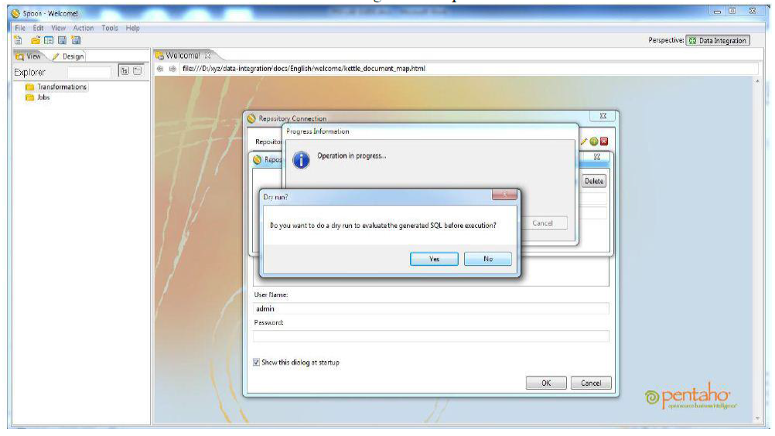

Figure:6

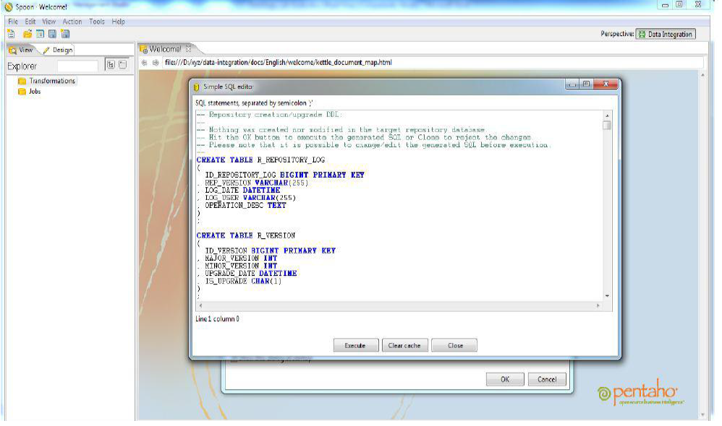

Figure:7

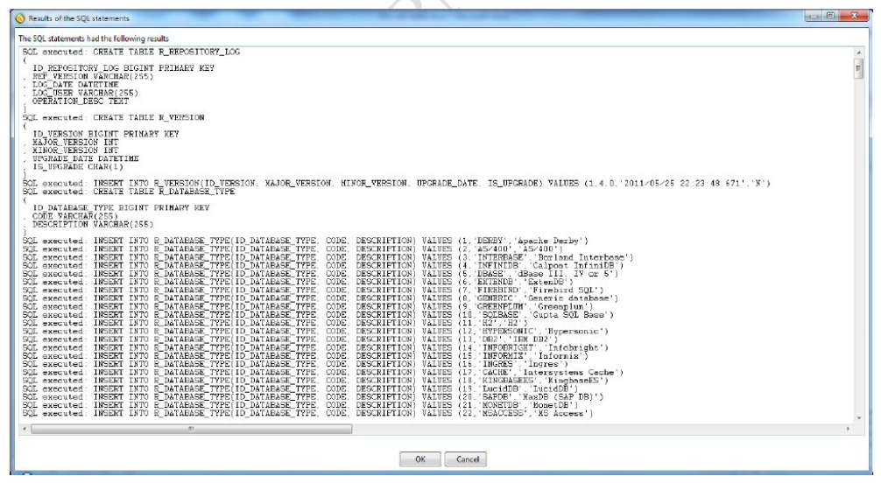

Figure:8

Creating a repository using the Kettle _le repository:-

Step 1: In the Repository Connection dialog box click on the + button. The Select the repository type dialog box will appear.

Step 2: Select Kettle _le repository and click on OK.

Step 3: Now in the File repository settings dialog box click on the Browse button, select a folder, fill the ID and Name, and click on the OK button.

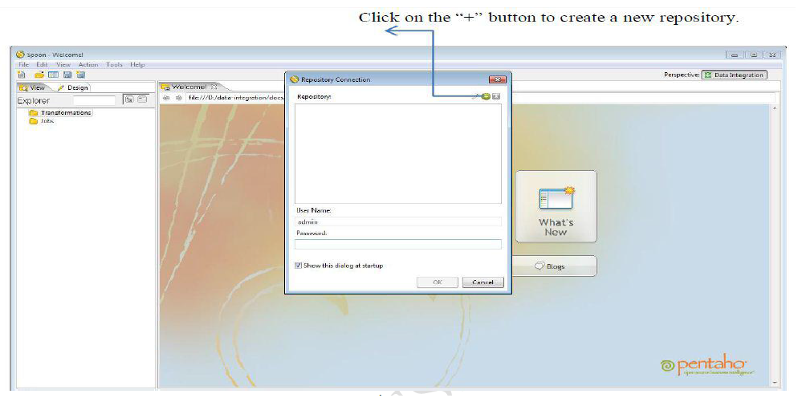 Figure:9

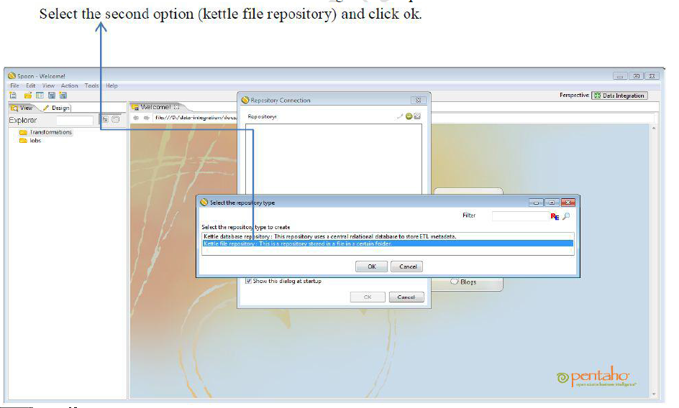 Figure:10

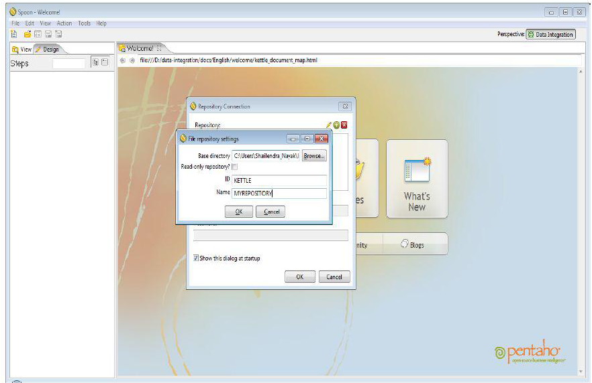 Figure:11

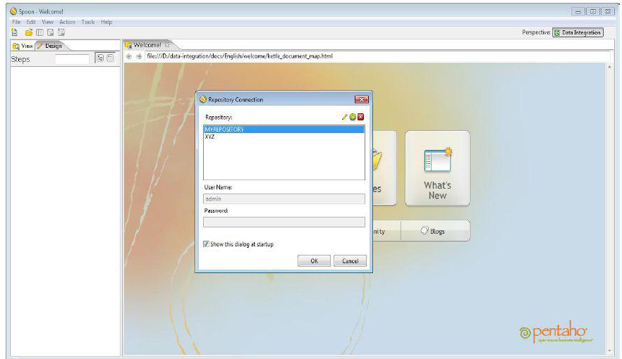 Figure:12

Repository Connection:-

Step 1: Normally the Repository Connection dialog box automatically opens with the opening of the Spoon window. If the Repository Connection dialog box does not open with the Spoon window or suppose you want to open it manually or you want to change your Repository, then: In the Spoon window from menu bar, click on Tools and select the Repository option and click on Connect to open the Repository Connection dialog box.

Step 2: To connect with your desired repository, select the corresponding repository name from the Repository Connection dialog box and click on OK. Note: In case of a database repository connection, you have to give User Name and Password (both are by default admin) and in case of a _le repository connection, User Name and Password are not required.

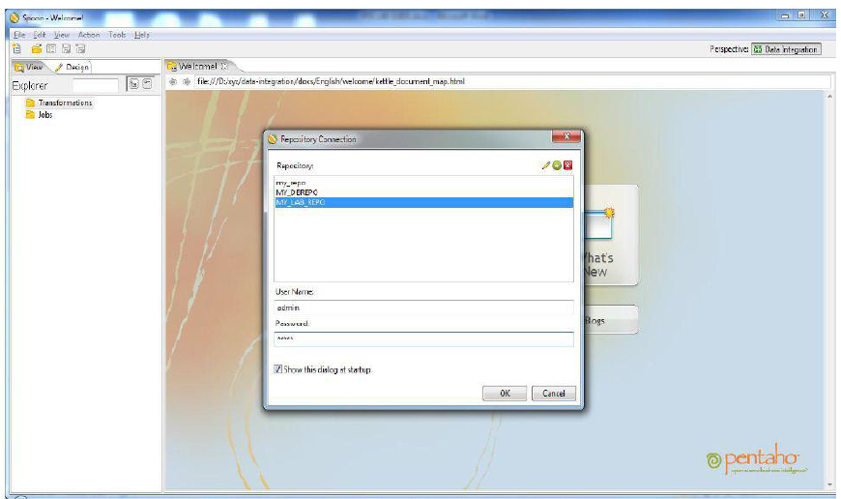 Figure:13

**Conclusion**: We have successfully performed the computation using Kettle tool.